NAME: VEDIKA NAIDU PRN: 24070521274
DNS PACKET ANALYSIS (Windows)
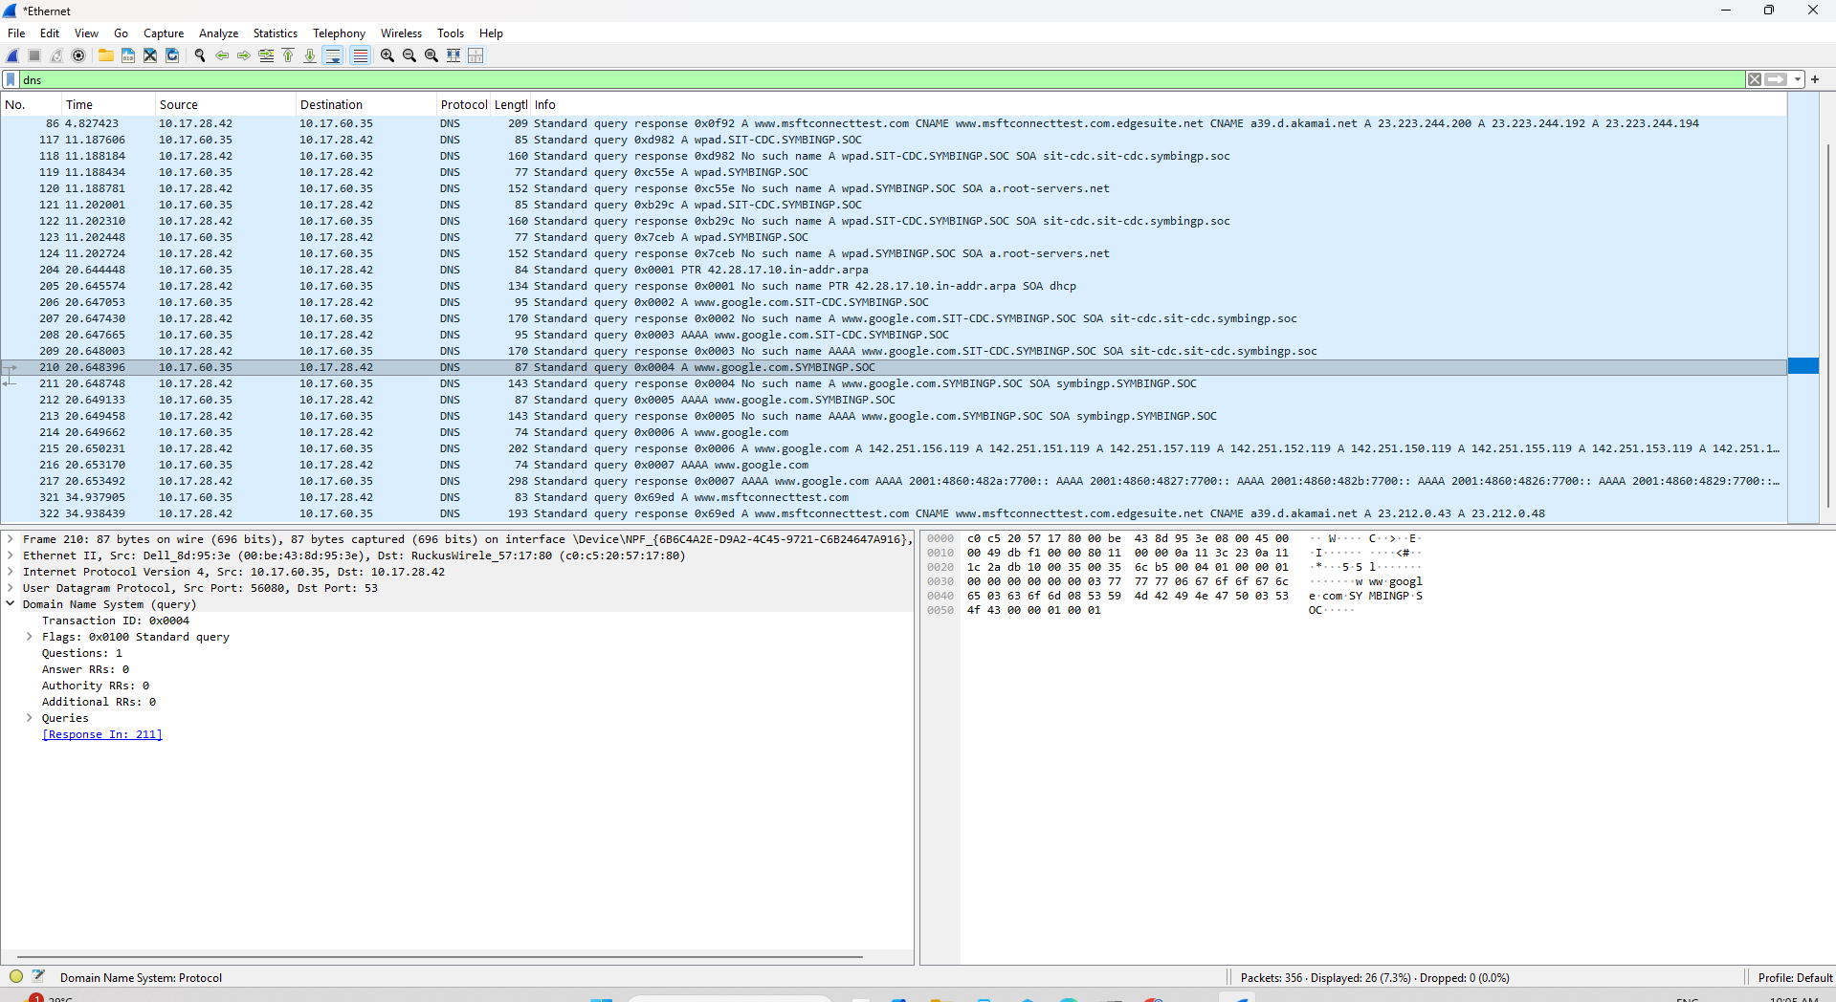

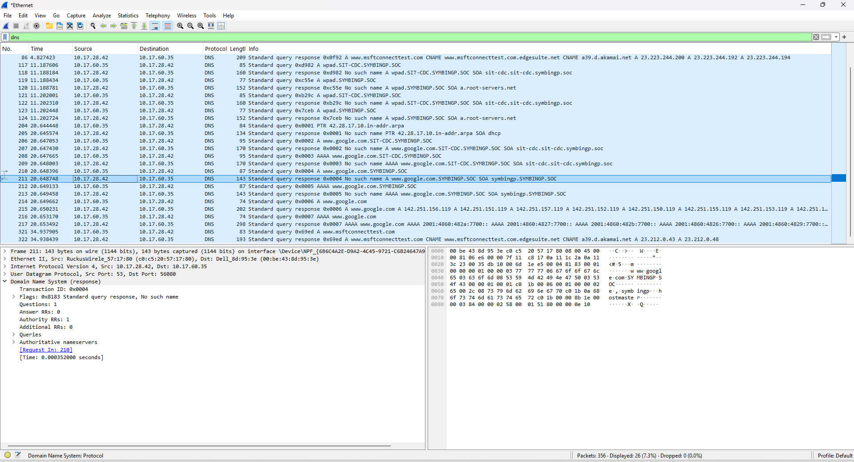

NAME: VEDIKA NAIDU PRN: 24070521274
